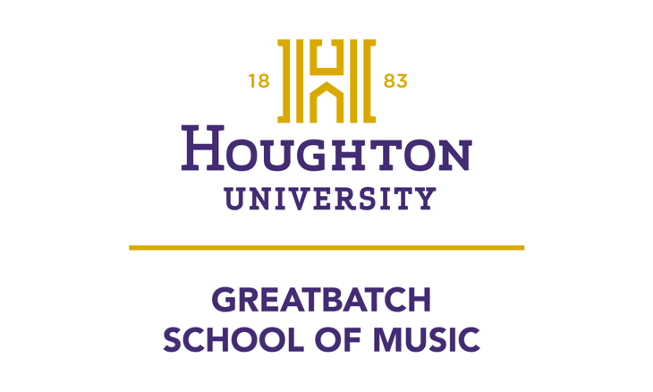
presents
First M. Last
Instrument/voice
in
Degree Name Recital

Assisted by
First Last, instrument
(repeat as needed)

Recital Hall
Center for the Arts
Day, MM DD, YYYY
0:00 p.m.

Program
Title (of piece or group) First M. Last
Sub-title or individual pieces (dates)
Performers

(Repeat above as needed through program; copy and paste format, then replace generic with specific, will best preserve formatting and will be easiest for most folks.)

Intermission/Pause
(Use Intermission for a break of 5:00 or longer, Pause for shorter times; joint recitals should generally NOT have a break, please.)

(Template is an option to be used if the program listing will be the second and following pages of a folded (4 half-sheet program.)

Program Notes

(See Music Student Handbook for Program Notes Guidelines)
If program notes can be contained on four sheets (not counting this one), they may be included in the program itself if using this format. Must work in increments of four pages to make the program work. If not, they should be printed as a separate, full-page, double-sided document. Translations should follow program notes in each section for vocal selections.

Spring ’23 Concerts and Events
2/1 7:30pm Lviv National Philharmonic Wesley Chapel
Orchestra of Ukraine
2/4 7:30pm 198th Army Concert Band Wesley Chapel
2/6 6:30pm Graduate Recital: Ethan Carr, composition CFA Recital Hall
2/6 8:00pm Junior Recital: Lydia Rech, voice CFA Recital Hall
2/8 8:00pm Student Performer Series CFA Recital Hall
2/11 all-day Wind Ensemble Festival Wesley Chapel
2/11 7:30pm Houghton Wind Ensemble Wesley Chapel
2/13 8:00pm Senior Recital: Emily Quick, voice CFA Recital Hall
2/15 8:00pm Faculty Recital: Angela McBrearty, flute CFA Recital Hall
2/20 8:00pm Senior Lecture Recital: Mikayla Bond, flute CFA Recital Hall
2/22 8:00pm Student Performer Series CFA Recital Hall
3/8 8:00pm Student Performer Series CFA Recital Hall
3/10 7:30pm Houghton Choir Wesley Chapel
3/13 8:00pm Graduate Recital: Rebekah Scharf, voice CFA Recital Hall
3/15 8:00pm Student Performer Series CFA Recital Hall
3/20 8:00pm Senior Recital: Linette Taylor, voice CFA Recital Hall
3/24 7:30pm Cecilia Ensemble CFA Recital Hall
3/30-4/1 7:00pm Lyric Theatre Wesley Chapel
4/12 8:00pm Faculty Recital: Andrew Reith, piano CFA Recital Hall
4/17 6:30pm Senior Recital: Adeline Roeske, composition CFA Recital Hall
4/18 7:30pm Jazz Ensemble Wesley Chapel
4/19 6:30pm Senior Recital: Rachel Huchthausen, piano CFA Recital Hall
4/19 8:00pm Student Performer Series CFA Recital Hall
4/21 7:30pm Men’s and Women’s Choir CFA Recital Hall
4/22 7:30pm Houghton Wind Ensemble Wesley Chapel
4/24 6:30pm Senior Recital: Rachael McVeigh, voice CFA Recital Hall
4/24 8:00pm Senior Recital: Luc Pereira, voice CFA Recital Hall
4/26 6:30pm Composition Recital I CFA Recital Hall
4/26 8:00pm Composition Recital II CFA Recital Hall
4/27 7:30pm Great “Batch” of Acts CFA Recital Hall
4/28 7:30pm Houghton Choir & Symphony Orchestra Wesley Chapel

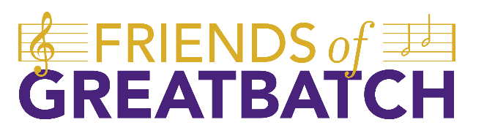

In support of music at Houghton University, we present Friends of Greatbatch, a giving society that benefits any Houghton student involved in our many musical programs. Your gift of any size is crucial to offering students outstanding musical experiences by providing the additional resources necessary to bring incredible masterclass instructors, world-class instruments and equipment, and additional learning and performing opportunities.

www.community.houghton.edu/friends-of-greatbatch

We would like to thank the Houghton University administration for its faithful support of the Greatbatch School of Music.
Dr. Wayne D. Lewis Jr., President
Dr. David Davies, Provost
Dale Wright, Chief Financial Officer
Greatbatch School of Music Faculty, Staff, and Administration

Name, a student of Dr. ADD NAME, is performing this recital in partial fulfillment of the requirements for the Bachelor of Music degree in ADD SPECIFIC STUDY (Piano Performance, Clarinet Performance, Music Education in …).
As a courtesy to the performer and your fellow audience members, please be certain that all cell phones, watch alarms, and pagers are either turned off or set for silent operation. Flash photography can be very disconcerting to performers and is not permitted during the performance. Thanks for your consideration.

